

**Asset Practice Questions: Mathematics**

1. If the MINUTE hand of a clock is at 6, the time shown by the clock could be

A. 9:20

B. 12:00

C. 2:30

D. 6:00

2. Here are Namita's and Jenny's shoes



They measure the length of their classroom using their shoes. With Namita's shoes, the room is 15 'shoes' long. What could be the length of the room when measured with Jenny's shoes?

A. 13 shoes long

B. 15 shoes long

C. 17 shoes long

D. 19 shoes long

3. How many 50-paise coins will Tina need to buy this kite?

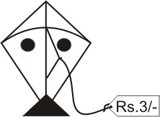

A. 3

B. 5

C. 6

D. 30



4. What number can fit in BOTH the boxes below to make the sentence true? 20 − = 10 +

A. 0

B. 5

C. 8

D. 30

5. 

- 6 = 14 + 5 What number comes in the empty



?

A. 6

B. 8

C. 19

D. 25

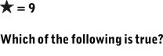

6.

A.  B. C. D.



7. What number comes in the empty box? 70 - 39 = - 59

A. 20

B. 50

C. 70

D. 90

8. What number goes in the box below to make the number sentence true?



A. 3

B. 13

C. 50

D. 57



9. What number comes in the empty box? 40 + 13 = 60 -

A. 7

B. 13

C. 17

D. 27

10. Which of the following is the same as 4 + 50 - 3?

A. 40 + 5 - 3

B. 90 - 3

C. 4 + 20

D. 1 + 50

11. See the number chart below. This is a '1 to 100' chart with three lines completed. The chart goes on the same way up to 100:

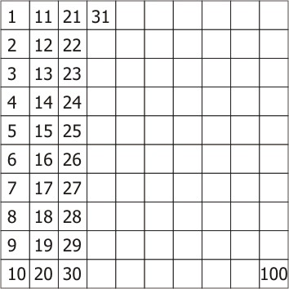

The number that comes in the box to the LEFT OF 54 in the chart is

A. 1 less than 54.

B. 1 more than 54.

C. 10 less than 54.

D. 10 more than 54.

12. 3 children wrote 3 different number sentences on the board.

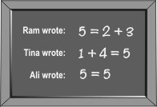

Which of the sentences are correct? A. All three sentences are correct.

B. Only Tina and Ali's sentences are correct.

C. Only Ali's sentence is correct.

D. Only Tina's sentence is correct.